|  |
| --- |
| OMR demo architecture PLANOM  Technical Specification |
| FORGEROCK 201 Mission St. Ste 2900  San Francisco, CA 94105 |



## HIMSS OMR Demo – Medical Devices

### Introduction

The OMR Demo was created by the Ecosystems Engineering Team to be presented at HIMSS 2018 in Las Vegas, March 5th to March 9th 2018.The purpose of the Demo was to showcase Forgerock’s Identity Platform capabilities to integrate with Health Care Related Cloud Services in order to collect data from Medical Devices and share the data with authorized parties only via UMA policies.

### Use Case: Nonin 3230 Pulse-Oximeter Data Collection

**Participants:**

Medical Provider (Doctor)

Consumer Patient (Patient)

QualcommLife (2Net SP)

Forgerock’s Identity Platform (FRIAMP)

Nonin 3230 Pulse-Oximeter (Device)

ACME Medical Provider Portal

Data Collection Mobile Application

**Scenarios:**

The Patient is prescribed a medical device as part of treatment for the patient’s condition. The Doctor assigns the Device to the patient’s account. The Doctor provides instructions to the Patient to sign in to the Provider’s Portal Web Application and ‘activate’ the prescribed device, and by doing so, the Device is enabled to collect data from the Patient and transmit it to a cloud service. The device is enabled only when the Patient agrees to the way in which data will be shared with the Medical Provider; this is accomplished by collecting the Patient’s Consent at Device Activation Time in the Provider’s Portal.

The Patient takes a reading with the Device. The process is as follows:

* The Patient pairs the Device via Bluetooth with his/her mobile phone.
* Upon successful pairing, the Patient opens the Data Collection Mobile Application on the phone and logs in using his/her user name and password.
* Once logged in to the Mobile Application, the Patient then clips the Device on a finger and waits for the green light indicator on the Mobile Application.
* This provides the indication to the Patient that a reading has been taken by the Device.
* The data read by the Device is sent to QualcommLife’s 2Net Services Platform (2Net SP), which in turn broadcasts the reading to a consumer service stood up by the Medical Provider’s Organization.
* Once the information is collected in the Medical Provider’s data stores (Implemented using FRIAMP), the Doctor can access the data on the ACME Medical Provider Portal.

## OMR Demo Architecture

### Overview

The architecture of the Demo has the following layers:

* Applications Layer
  + Medical Provider Portal Web Application
  + Mobile Device Medical Application – Data Collector
* Cloud Services Layer
  + 2Net Cloud Services Platform
  + ACME Medical Data Consumer End-Point
  + ForgeRock Identity and Access Management APIs
    - Provisioning
    - Relationship Management
    - UMA
    - Authentication/Authorization
* Storage Layer
  + OpenIDM Data Store
  + OpenDS Directory Services – User Store
* Physical Layer
  + Medical Devices – 2Net Compatible
    - Nonin 3230 – Pulse Oximeter

The associations and dependencies amongst the components described above is shown in the diagram below:

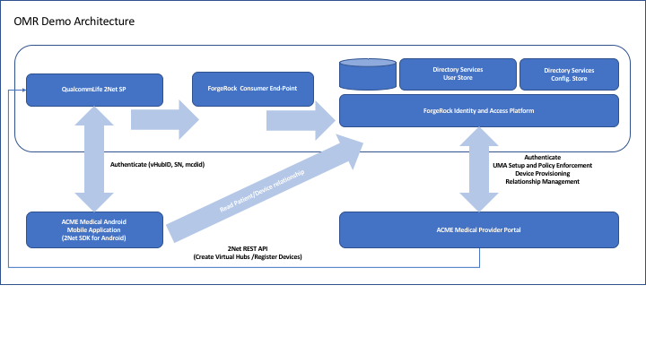

As described in the picture above the ACME Medical Android Mobile Application communicates with the QualcommLife Cloud Services Platform using the Android SDK (Qualcomm Provides an IOS version of the SDK for iPad and iPhone applications).

The communication between the Mobile Application and the 2Net Cloud Services Platform has the purpose of authenticating the mobile device using the virtual hub associated to the Medical Device, an authentication code associated to the Device’s owner (Patient) and a digital signature for the Android Device being used to collect the data (MCDID) from the Medical Device (Patient’s Phone). Once the Device is authenticated, if someone else tries to login to the user’s account with a different Mobile Device, even if the credentials are compromised, this person won’t be able to connect and take any measurements with the associated Medical Device.

The ACME Medical Provider Portal establishes the relationship between a Patient and a Device by generating an Authentication Code and use it to create a Virtual Hub on 2Net Cloud Service Platform. The Portal uses REST APIs to communicate with 2Net CSP. This process needs to be completed before the data is collected and before the Doctor can get access to the Patient’s Device collected data.

When ACME Medical Provider Portal activates the Device, it also generates an UMA resource and an UMA policy giving access to the Doctor associated to the Patient. All these relationships are created and maintained in OpenIDM. Then this information is retrieved by the Mobile Application and the Portal when the Patient takes a reading and when the Doctor attempts to access a Patient’s data.

ForgeRock’s Identity and Access Management Platform also provides User Authentication and Authorization for Doctors and Patients.

## Implementation

### Demo Applications

#### ACME Medical Provider Portal

This is a Web Application developed using Grails Framework. It is written in Groovy. The source code is located under the OMRAdminPortal subdirectory of the GitHub repository.

The IDE used for Development is IntelliJ IDEA by JetBrains, so the whole project is available in the repository under the OMRAdminPortal subdirectory as well.

The application is based on MVC architecture and leverages Spring framework for configuration management and internal bean wiring (Dependency Injection) – for more information about the Spring Framework please refer to the following link: <https://spring.io/>

The following diagram shows the relationships between the Domain objects in the Architecture:

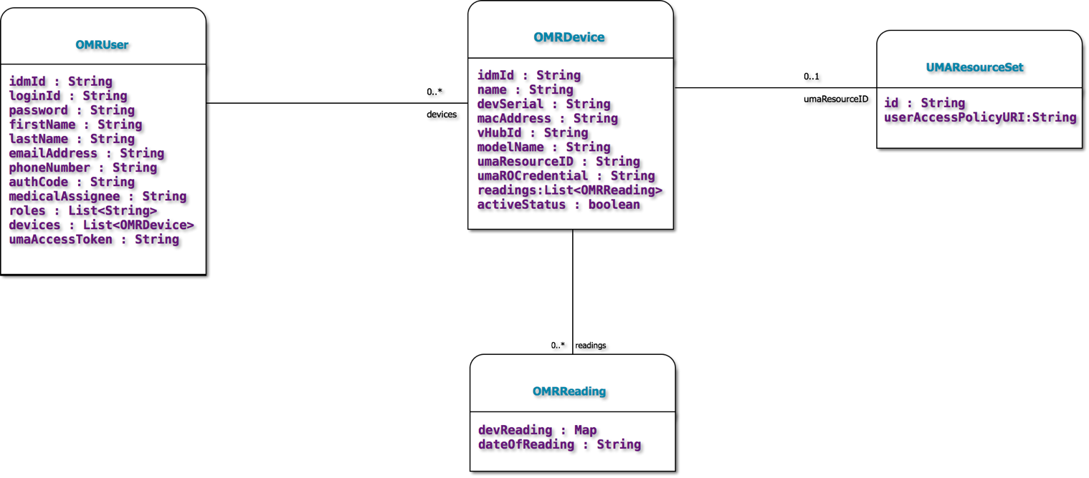

###### OMRDevice

This class represents the Medical Devices that Doctors prescribe to Patients. The fields significant to the implementation with 2Net SP are:

* macAddress: This is the BTLE address the Patient’s mobile phone gets at pairing time.
* devSerial: This is the Device’s Serial Number which is tied to the MAC Address above
* vHubId: This is a unique identifier assigned by 2Net SP, and it represents the Patient’s Mobile Phone serving as a Virtual HUB. This is the link between the Medical Device and the cloud service exposed by 2Net SP.
* modelName: This is the Manufacturer Model of the Medical Device. This is also associated to the Device’s SN to make sure the type of device matches the provisioning record for the Device in 2Net SP’s Database.

The fields used for UMA grant flow implementation are the following:

* umaResourceID: This is the Id of the resource representing the Medical Device. This is used to create Resource Types and UMA Policies.
* umaROCredential: This is the Patient’s login credential which is used to obtain a PAT (Permission Access Token) used in the UMA Grant Flow to issue RPTs to Requesting Parties trying to access the Patient’s Medical Device data. For more information about UMA please review the following references: <https://docs.kantarainitiative.org/uma/rec-uma-core.html>.

###### OMRUser

This class is used to represent both Patients and Doctors. The difference is determined by the Roles that this user is a member of. Patients have no roles, Doctors do have roles. There are some attributes of this class that are used primarily during UMA grant flows, specifically the umaAccessToken. The umaAccessToken is the PAT for a Patient and the RPT for the Doctor.

###### OMRReading

This class is used to represent a Medical Device Reading. Instances of this class are associated to a given device via the readings attribute in the OMRDevice class. The readings attribute is a list of instances of class OMRReading. The attribute that contains the information of the reading is a map of reading attributes. Each reading may contain multiple pieces of information, for instance: The pulse oximeter communicates two pieces of data: the Patient’s Heart Rate and the SP0 index (Oxygen Level). The best way to represent that was to store each individual piece of data as an entry in a Map object, that is why the devReading attribute is of type Map.

###### UMAResourceSet

This class represents the Medical Device as an UMA Resource. This is used in the UMA Grant Flow to get access by the Doctor to the Patient’s Medical Device data. This is a very simple class which has just two attributes, and each instance of this class are associated to one and only one corresponding instance of a Medical Device (OMRDevice). The relationship is represented by attribute umaResourceID in class OMRDevice.

The Managed Objects in OpenIDM used in the OMR Demo are shown in the picture below:

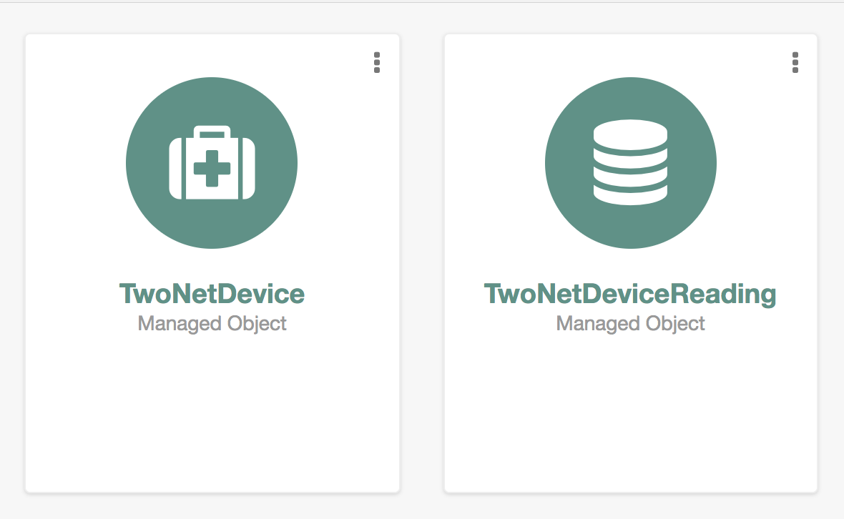

The following pictures show the attributes of each Managed Object:

**TwoNetDevice**

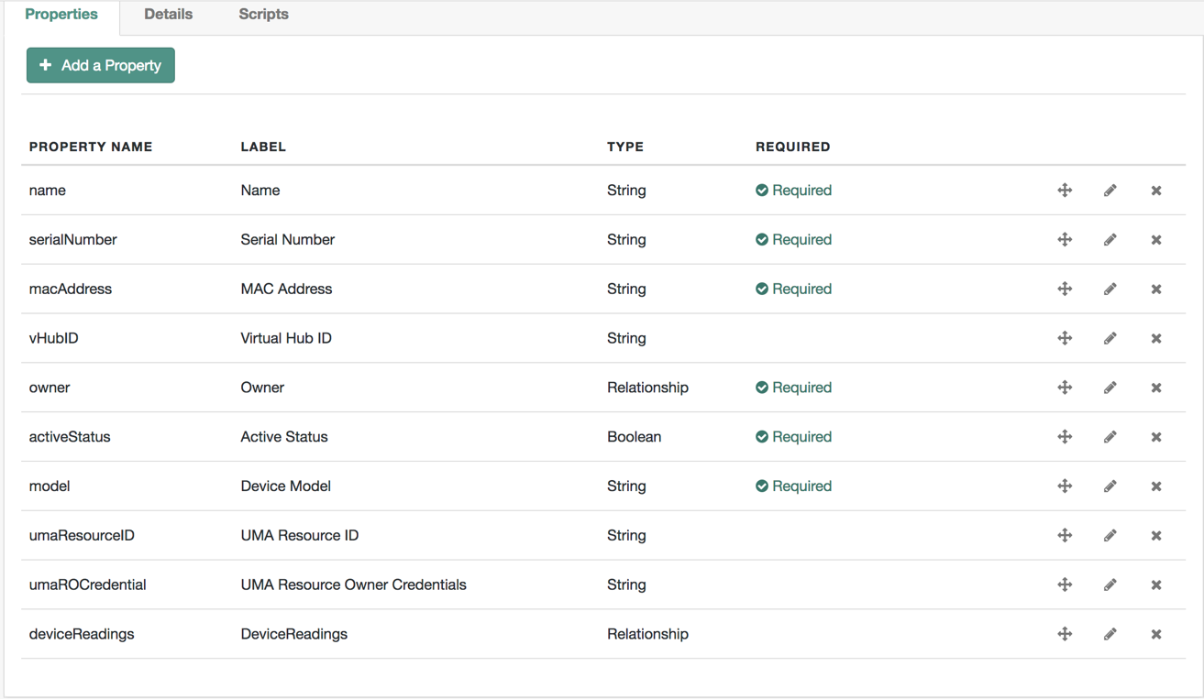

**Attribute owner Relationship Configuration**

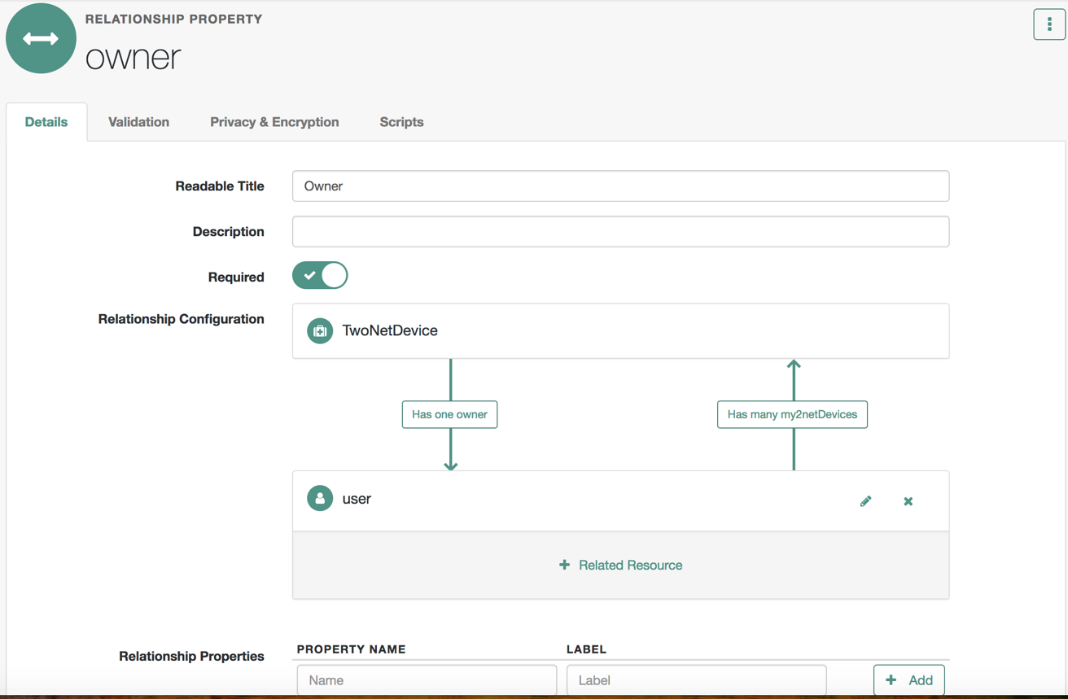

**Attribute devicesReadings Relationship Configuration**

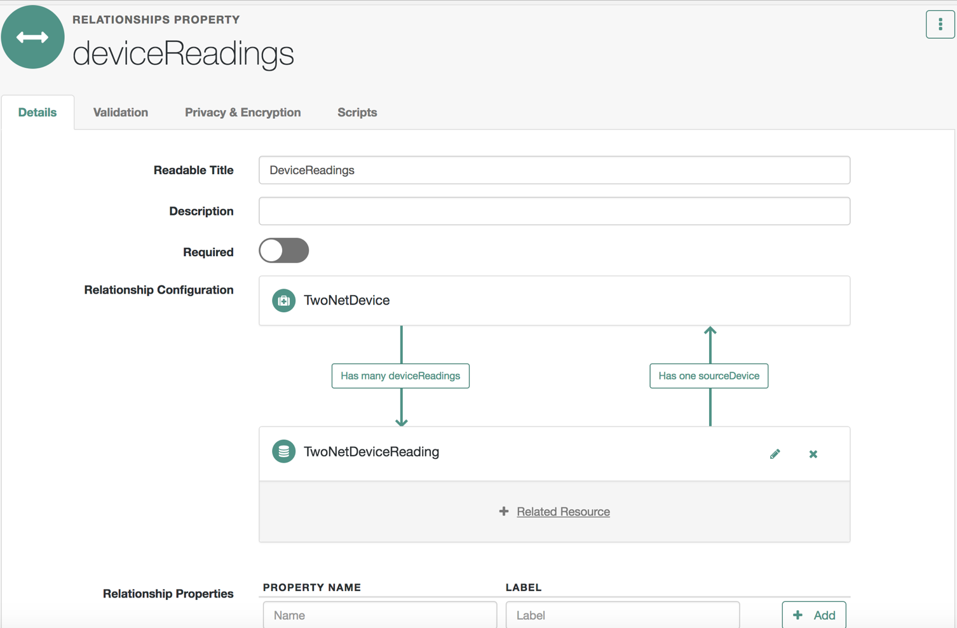

**TwoNetDeviceReading**

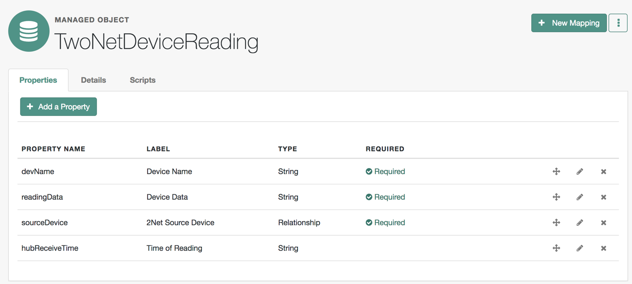

**Attribute sourceDevice relationship configuration**

